Logic in Programming

🧠 What is Logic?
# Source: AI Source: Provided by: [Data Path: Persons Table -> ID Column: 1, Name_En Column: Motasem Essam] -> From: [Chatgpt (GPT‑5 Mini)] on [12/9/2025]
Logic is the process of reasoning and making decisions based on rules or conditions.
👉 In simple terms:
Logic = how you think step-by-step to solve a problem

🔑 Simple Definition
# Source: AI Source: Provided by: [Data Path: Persons Table -> ID Column: 1, Name_En Column: Motasem Essam] -> From: [Chatgpt (GPT‑5 Mini)] on [12/9/2025]
Logic is the set of rules that determine what should happen and when

🧩 Everyday Example
# Source: AI Source: Provided by: [Data Path: Persons Table -> ID Column: 1, Name_En Column: Motasem Essam] -> From: [Chatgpt (GPT‑5 Mini)] on [12/9/2025]
👉 If it’s raining → take an umbrella
This is logic:
IF raining THEN take umbrella

💻 Programming Example
# Source: AI Source: Provided by: [Data Path: Persons Table -> ID Column: 1, Name_En Column: Motasem Essam] -> From: [Chatgpt (GPT‑5 Mini)] on [12/9/2025]
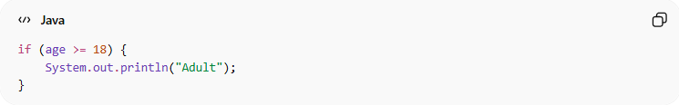
if (age >= 18) {
System.out.println("Adult");
}
👉 Logic here:
- Check a condition (age >= 18)
- Make a decision based on it

Types of Logic in Programming

1️⃣ Conditional Logic
# Source: AI Source: Provided by: [Data Path: Persons Table -> ID Column: 1, Name_En Column: Motasem Essam] -> From: [Chatgpt (GPT‑5 Mini)] on [12/9/2025]
- Uses if, else, switch
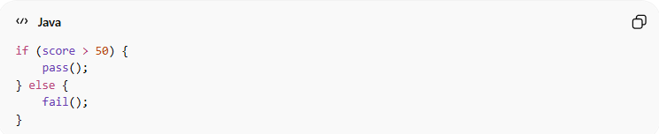
if (score > 50) {
pass();
} else {
fail();
}

2️⃣ Looping Logic
# Source: AI Source: Provided by: [Data Path: Persons Table -> ID Column: 1, Name_En Column: Motasem Essam] -> From: [Chatgpt (GPT‑5 Mini)] on [12/9/2025]
- Repeats actions
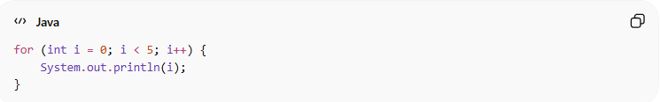
for (int i = 0; i < 5; i++) {
System.out.println(i);
}

3️⃣ Business Logic
# Source: AI Source: Provided by: [Data Path: Persons Table -> ID Column: 1, Name_En Column: Motasem Essam] -> From: [Chatgpt (GPT‑5 Mini)] on [12/9/2025]
- Rules that define how the system works
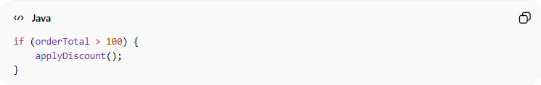
if (orderTotal > 100) {
applyDiscount();
}
👉 This is based on real-world rules

❌ Bad Logic Example
# Source: AI Source: Provided by: [Data Path: Persons Table -> ID Column: 1, Name_En Column: Motasem Essam] -> From: [Chatgpt (GPT‑5 Mini)] on [12/9/2025]
if (x == 1) {
doSomething();
} else if (x == 2) {
doSomething();
}
👉 Repeated logic → unclear

✅ Good Logic Example
# Source: AI Source: Provided by: [Data Path: Persons Table -> ID Column: 1, Name_En Column: Motasem Essam] -> From: [Chatgpt (GPT‑5 Mini)] on [12/9/2025]
if (x == 1 || x == 2) {
doSomething();
}
👉 Clear and simple

💡 Key Idea
# Source: AI Source: Provided by: [Data Path: Persons Table -> ID Column: 1, Name_En Column: Motasem Essam] -> From: [Chatgpt (GPT‑5 Mini)] on [12/9/2025]
Logic is how your program thinks and makes decisions

🧾 Summary
# Source: AI Source: Provided by: [Data Path: Persons Table -> ID Column: 1, Name_En Column: Motasem Essam] -> From: [Chatgpt (GPT‑5 Mini)] on [12/9/2025]
Logic helps you:
- Solve problems step by step
- Control program flow
- Make decisions in code
- Implement real-world rules in software

